Step 1: Create Loan Prediction folder in Google drive.
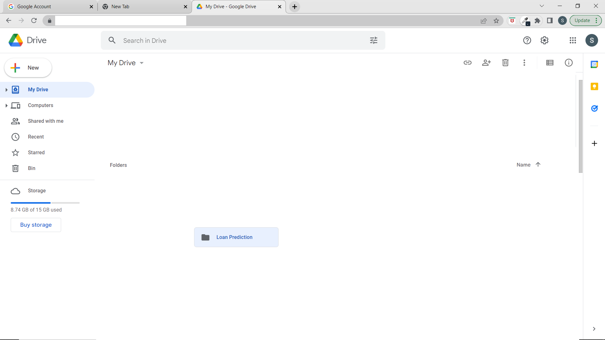
Step 2: Create Data Files and Model Training Folder in Loan prediction folder.
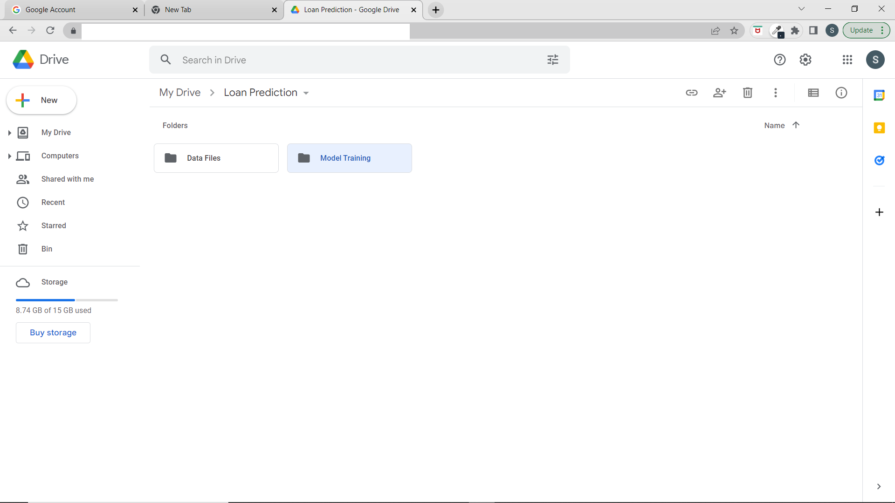

Step 3: Copy train csv file in Data Files folder in local device and paste it in Data Files in Google Drive.

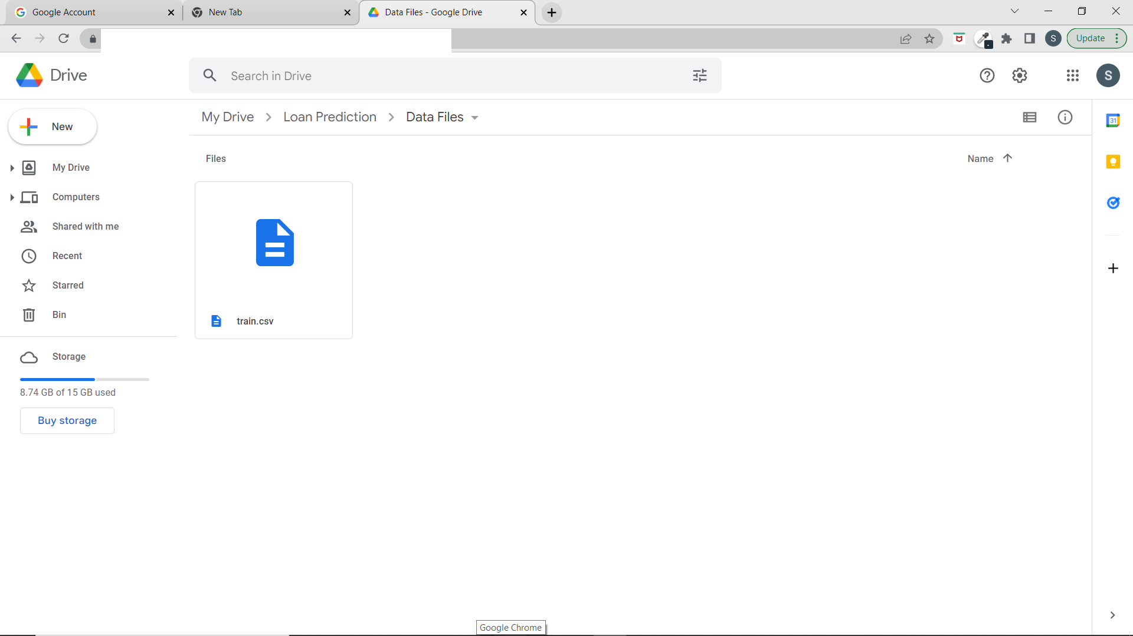

Step 4: Copy all files in Model Training from local and paste all files in Model Training in Google drive.

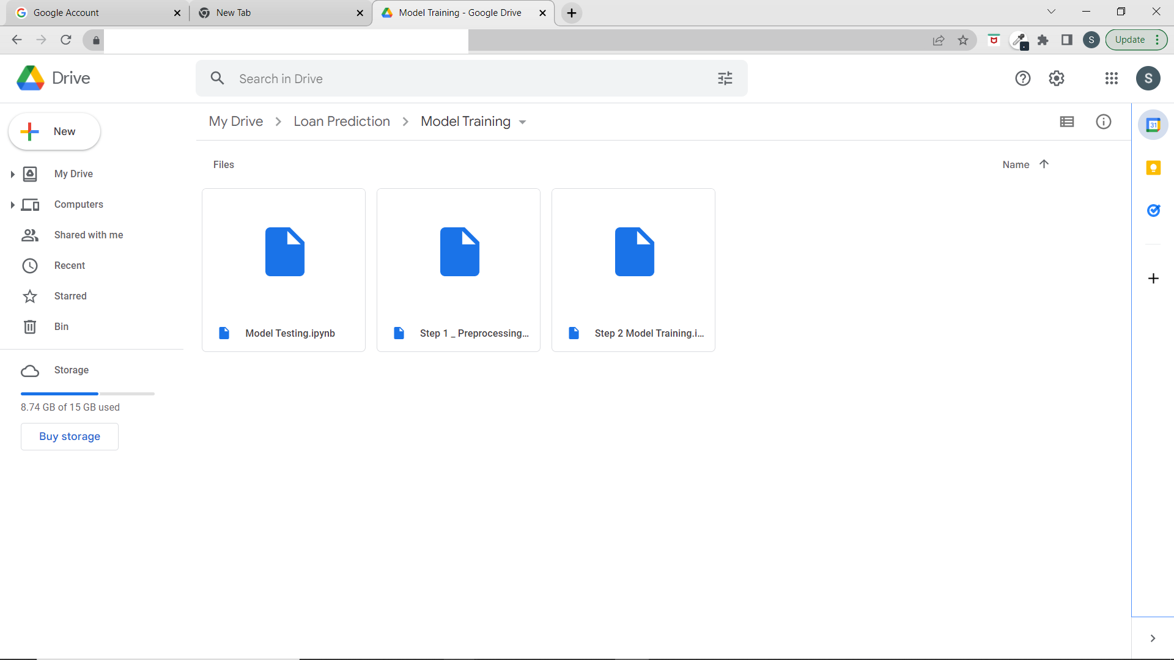

Step 4: Run Data Preprocessing File. After running this file, processed file csv will be stored in the Data Files folder.
Step 5: Run Model Training File. After running this file all trained model files will be stored in Data Files Folder.

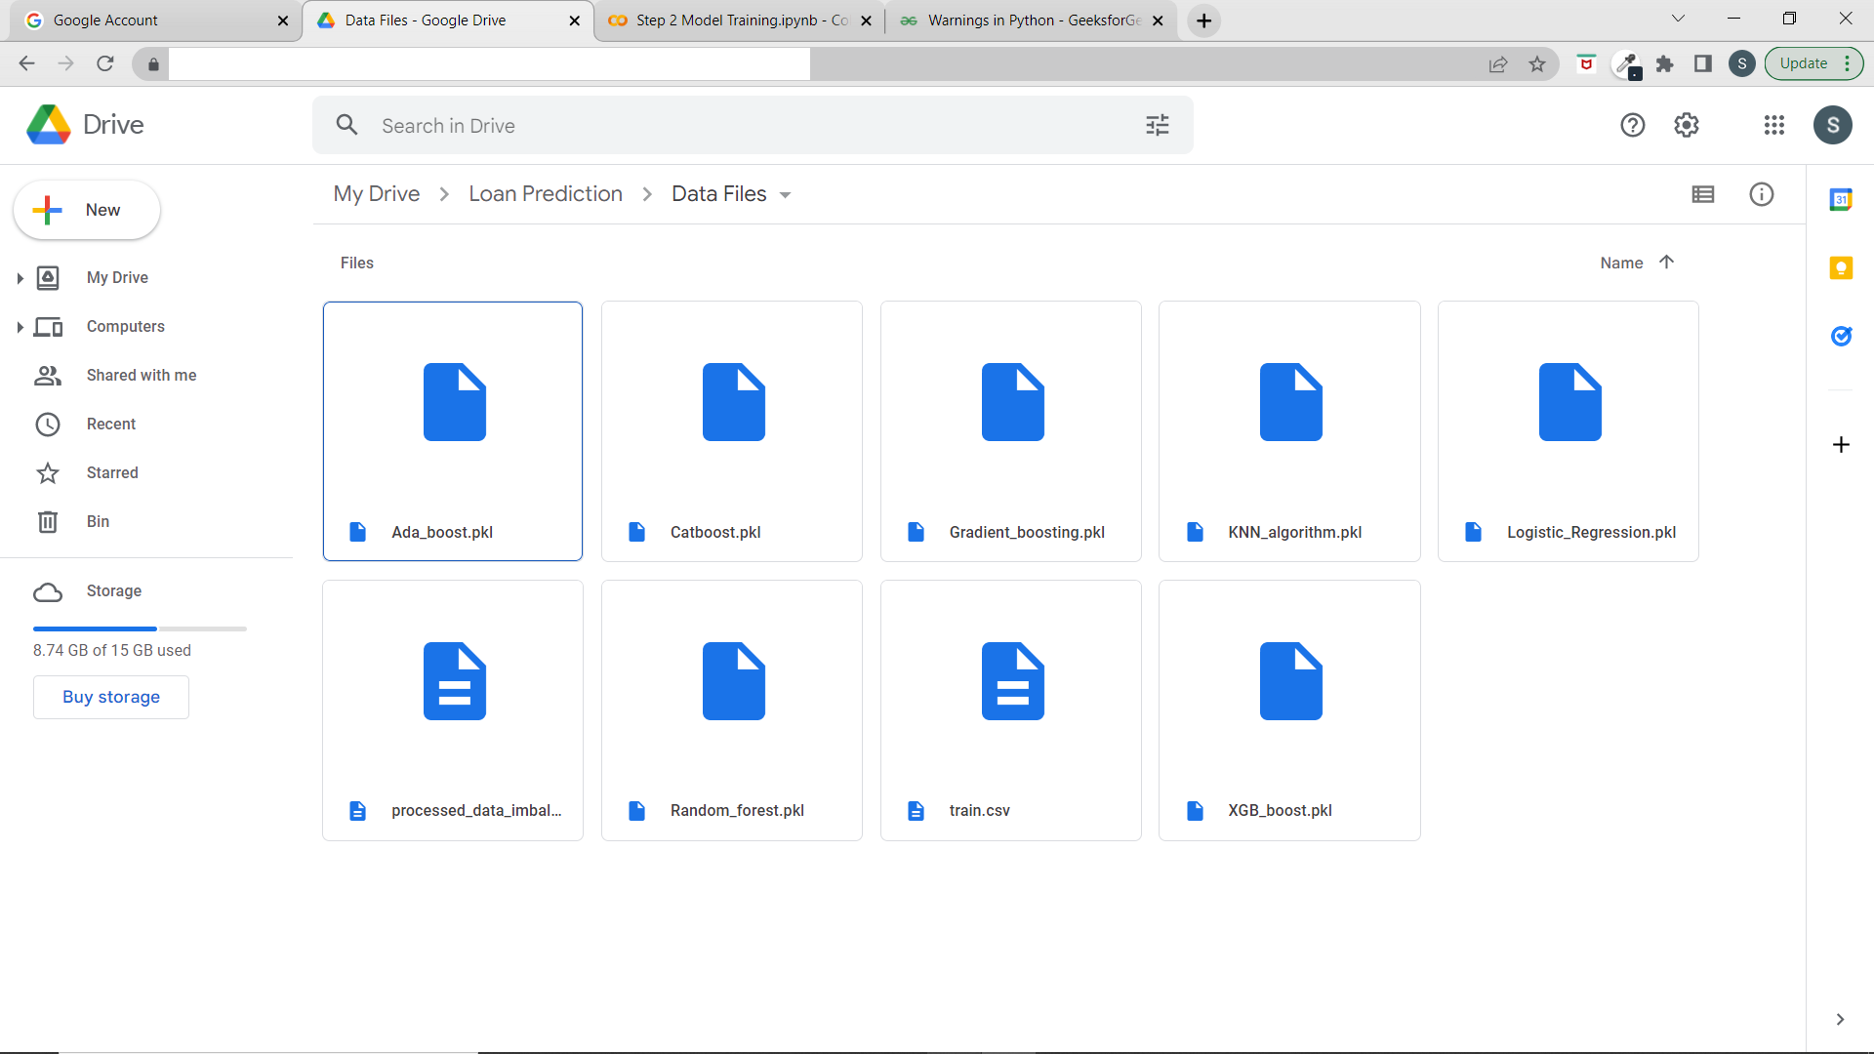

Step 6: Copy all model Files in Google drive and paste these model files in data files folder in local device.
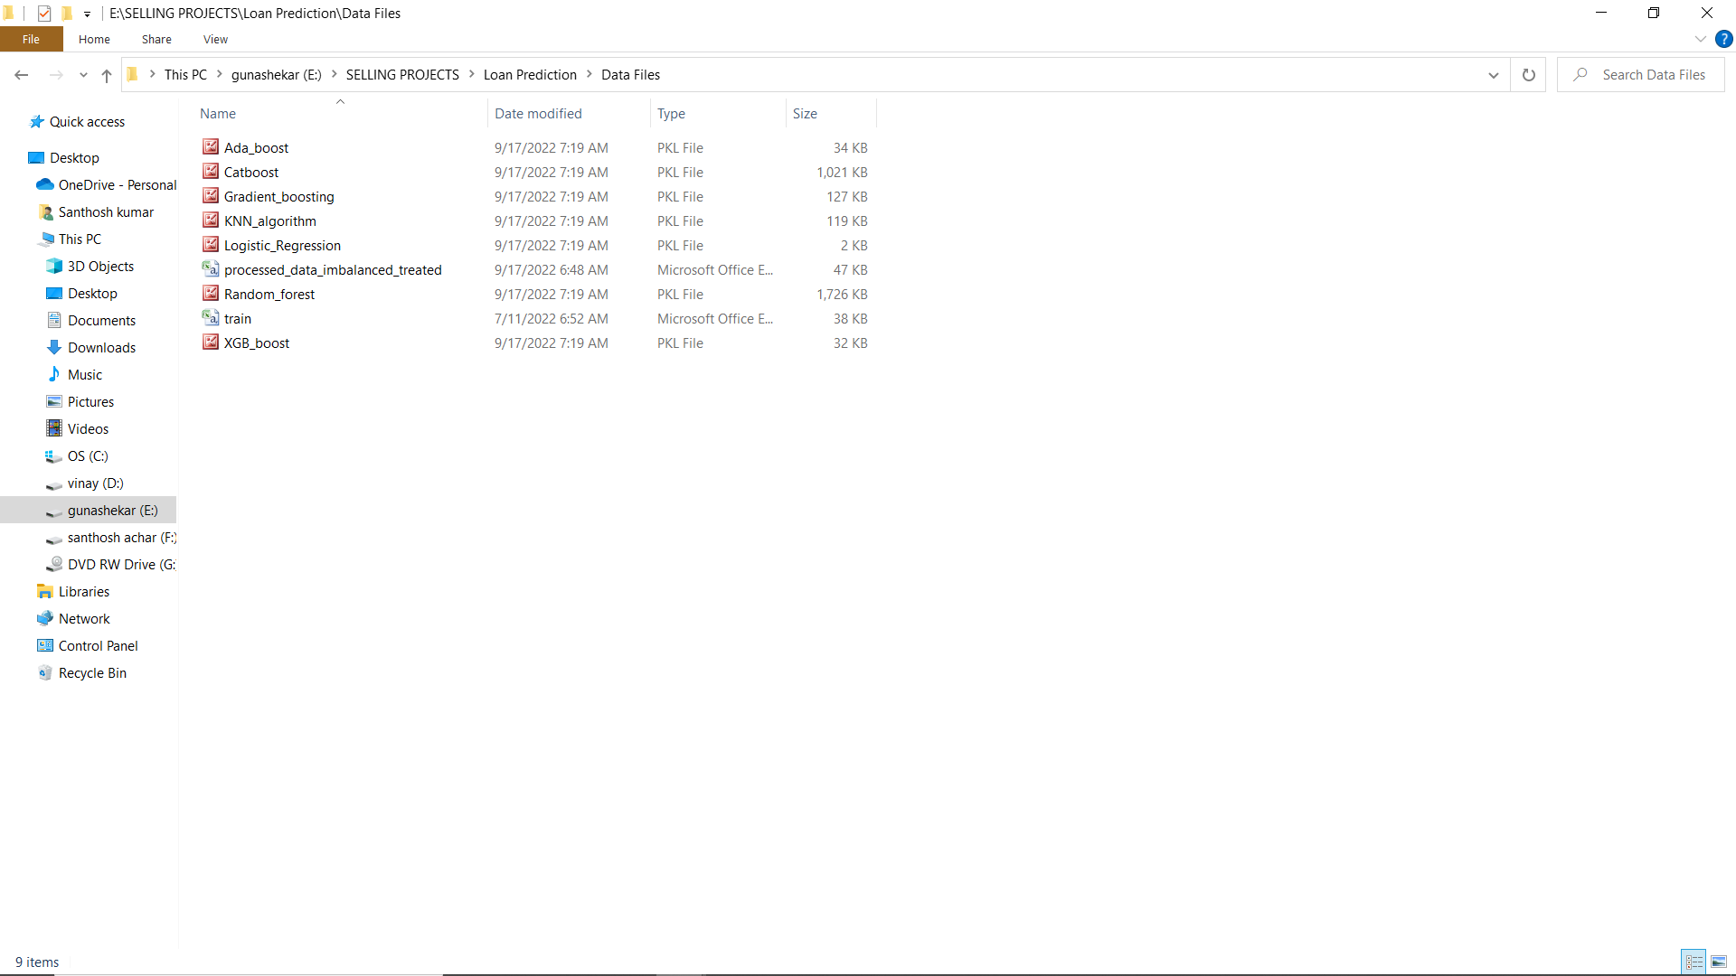

Step 7: Open command prompt and working directory should be the root folder of the project.
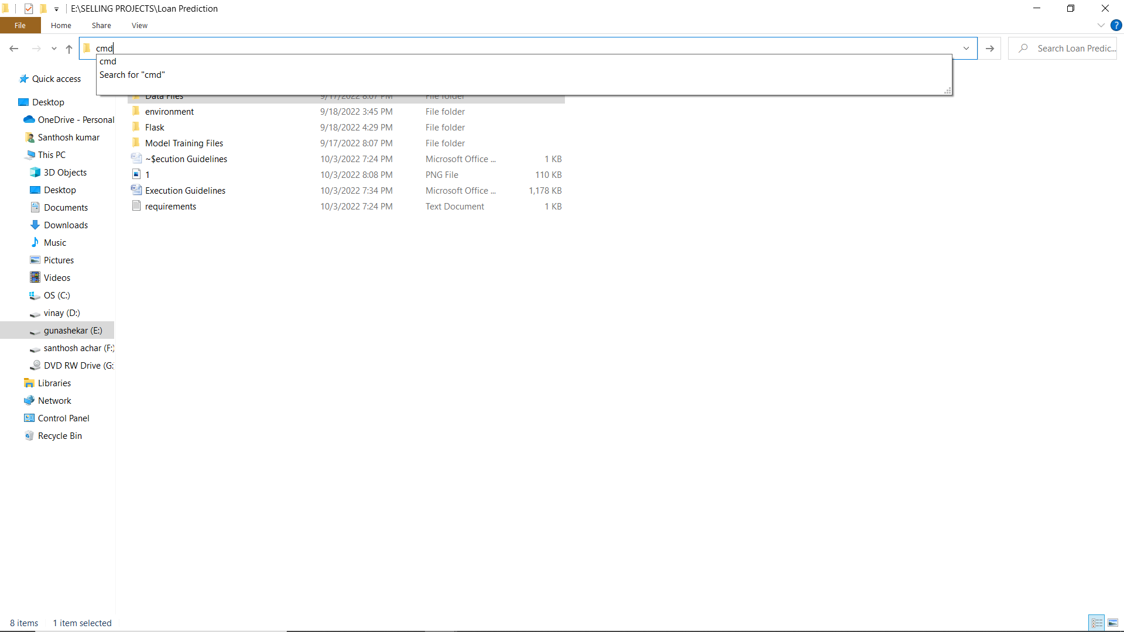
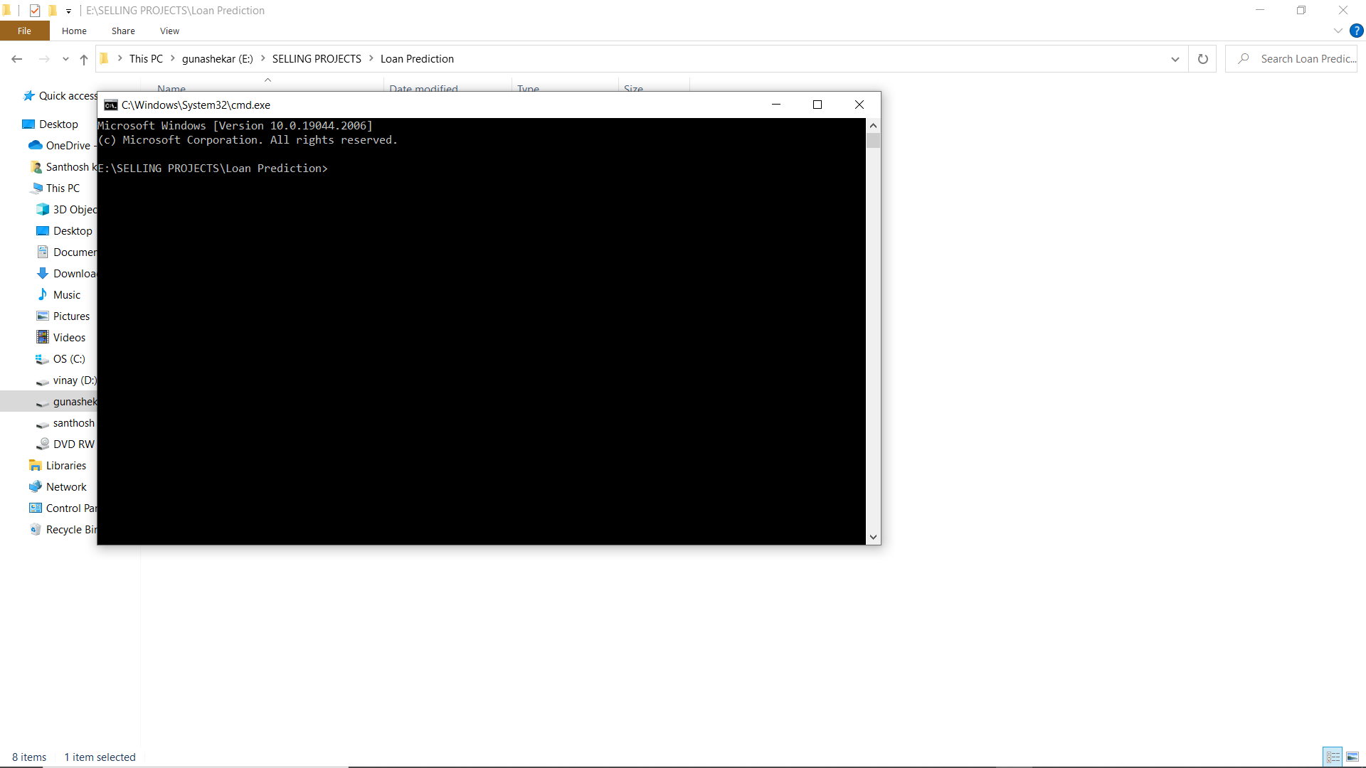

Step 8: Create virtual environment.
- pip install virtualenv
- virtualenv environment
- environment\scripts\activate
Step 9: Install required packages.
- pip install –r requirements.txt.
Step 10: change the working directory to flask.
- cd Flask

